**Q.1**

**Solution:**

∑ = {1, 2}, F = {4rs}, qo {0rs}, Q = {0rs, 1rs, 2rs, 3rs, 4rs}

**Transition Table:**

|  |  |  |
| --- | --- | --- |
| **State** | **Input** | |
| **1** | **2** |
| 0rs | 1rs | 2rs |
| 1rs | 2rs | 3rs |
| 2rs | 3rs | 4rs |
| 3rs | 4s | 0rs |
| 4rs | 0rs | 0rs |

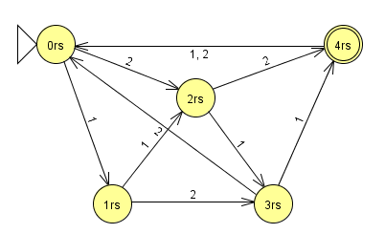

Q2.

a.

The language L of string which does not contain the substring bb and ends in a defined over alphabet

{a, b}.

Solution:

R.E

(a + ba)* (λ + b) a

FA

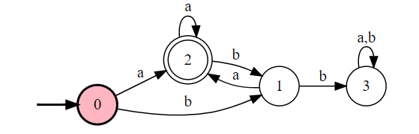

b. Construct the FA for the following regular expression.

1*(0*01*)*+1+0+$. **(Its bit tricky so I would suggest this to include. It would enable students to think).**

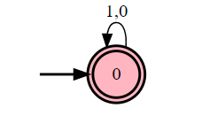

c.

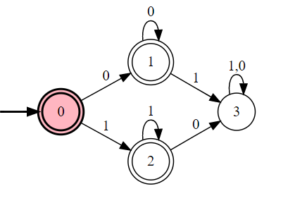

**Q.3**

**) L1 the set consisting of the strings 0, 11, and 010**

**0+11+010**

**b) L2 the set of strings of three 0s followed by two or more 0s, containing no 1s**

**00000+**

**c) L3 the set of strings of odd length**

**(a+b)((a+b)(a+b))\***

**d) L4 the set of strings that contain exactly one 1**

**0*10\***

**e) L5 the set of strings ending in 1 and not containing 000**

**f) The set of strings containing a string of 1s such that the number of 1s equals 2 modulo 3, followed by an even number of 0s**

**11(111)*(00)\***

Q.4

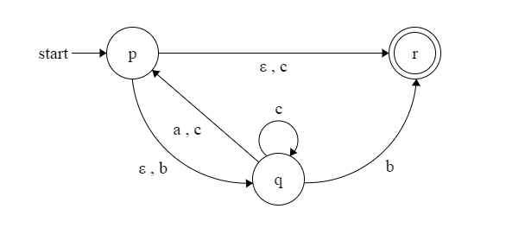

|  |  |  |  |
| --- | --- | --- | --- |
| States | A | B | C |
| P | {p,q,r} | {q,r} | {p, q, r} |
| Q | {p,q,r} | R | {p,q,r} |
| R | Null | Null | Null |

|  |  |  |  |
| --- | --- | --- | --- |
| States | A | B | C |
| P | {p,q,r} | {q,r} | {p, q, r} |
| {p, q, r} | {p, q, r} | {q,r} | {p,q,r} |
| {q,r} | {p,q,r} | R | {p,q,r} |
| R | Null | Null | Null |
| Null | Null | Null | Null |